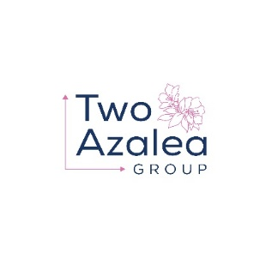
Two Azalea Group, LLC – Ability One/Skilcraft
A Small Business Administration (SBA) certified Service-Disabled Veteran Owned Small Business (SDVOSB) laser focused on providing AbilityOne/Skilcraft manufacturing partners and their distributors with local sales and marketing expertise.

The Opportunity:
The Skilcraft brand was born out of the Wagner-O’Day Act passed by the 75th US Congress in 1938. In 1971 Congress expanded the bill under the leadership of Senator Jacob Javits to become the Javits-Wagner-O’Day act responsible for mandating federal agencies purchase supplies and services from workshops for the blind and companies employing severely handicapped Americans. Today, dozens of US companies partner with NIB agencies to manufacture products to be sold under the Skilcraft Brand. While mandates are a good and powerful thing, most do not “sell themselves” and need field based support with industry expertise to adequately implement, maintain and grow the business. Cleaning products, in particular, are often used improperly meaning end users and their customers should both benefit from field level expertise and support.
- The Federal Government purchases hundreds of millions of dollars of Skilcraft brand products today.
- Most primary product manufacturers sell components to Ability One workshops where there are assembled for final use and support ends there.
- End Users need to be trained to use cleaning products properly and safety which increases effectiveness and and efficiently.
Our Mission:
We exist to be your partner to federal government agencies:
- Helping you position your products or services
- Introducing your products, training the end user on proper applications/use and maintaining local relationships which will ultimately increase your revenue and profitability while providing immeasurable value to the end user.
- Becoming stickier to the customer with real solutions - not just a low bid resulting in repeatable success

Our Vision:
Proving hands on, expert, local support to Federal end users in the use of mandated products provided by National Industries for the Blind workshops .

What does that mean to our partners?
We intend to represent companies with value-added products which deliver solutions for real world customer problems. We will bundle products from multiple manufacturers into a total value package to provide our mutual customers. This approach will make each of us more valuable to them by solving their business issues both known and unknown.

Why do we exist?
- Manufacturers and distributors desire to conduct business with Government entities but many don’t know how and most do not have a preferred status.
- The US government sets aside contract benefits for companies certified as “Service-disabled Veteran-owned Small Business” (SDVOSB). The most notable of these contracts is the Veterans Government-wide Acquisition Contracts (VETS-GWAC) which has an annual ceiling of $5 billion.
- Companies who do not qualify as a SDVOSB must partner with a SDVOSB to gain access to this large pool of government spend.

These are three critical points the Two Azalea Group addresses:
- We give you access to contracts you normally could not access or win
- We bundle your products into a total value package to make each of us more valuable to our end users
- We solve important customer business issues, making us exponentially more valuable to our end users

